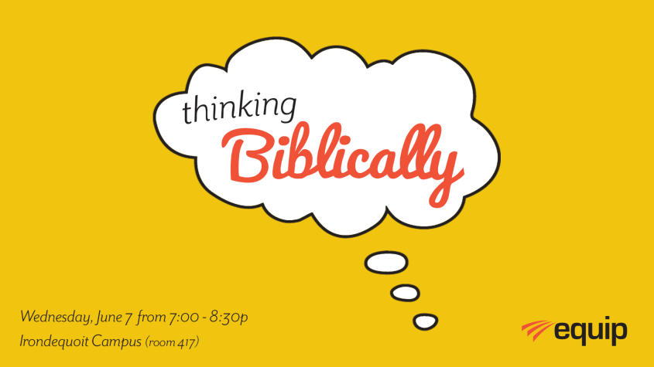

Introduction
- “As he thinks within himself, so he is.” (Proverbs 23:7a NASB)
- Traffic lights

- Presuppositions
- The Bible is God’s inspired and authoritative word for us – It’s our source of truth for living (2 Peter 1:3).
- God intends for us to interpret His word literally, grammatically, and historically (2 Timothy 3:16-17).
- Jesus Christ is the Central, redeeming figure of the Bible (Isaiah 53; I Corinthians 15).
- When the Fall occurred man was fundamentally broken in every way – Spiritually, mentally, physically, relationally, socially, emotionally (Genesis 3; Romans 3).
- The only solution to man’s brokenness is the forgiveness of sins through faith in Jesus Christ alone, and Christ-followers living by that saving grace every day (Romans 5; Ephesians1-2).
- People’s attitudes, actions, and words are based on what and how they think (Proverbs 23:7; Ephesians 4:22-24)
  - About God
  - About man
  - About salvation
  - About everything
- Defining our terms

- Thinking
  - To form or have in the mind, an intention, to reflect, consider, ponder, remember, anticipate, expect, judgment, conception, meditate.
  - "That thinking is a subject of great importance becomes clear when you see how often the words ‘mind’, ‘thought’ and ‘heart’ keep cropping up in the Bible. There are well over one thousand such references. Thinking, therefore is of critical importance to God.”
- “Biblically”
  - “Relating to, taken from, or found in the Bible”

- Thinking Biblically
  - Thoughts, judgments and desires that are filtered, percolated, and purified through God’s word; they are in submission to Christ.
  - Other related terms
    - Biblical discernment (Hebrews 5:11-14)
    - Biblical/Christian worldview (Romans 12:2))
    - Christ-centered, godly thinking (Colossians 2)
- A survey of Scripture

- God’s thoughts and words are life transforming!
  - Isaiah 55:8-9 “For my thoughts are not your thoughts, neither are your ways my ways,” declares the Lord. ⁹ “As the heavens are higher than the earth, so are my ways higher than your ways and my thoughts than your thoughts.
  - Isaiah 40:13 Who has known the mind of the Lord so as to instruct Him?
  - Hebrews 4:12-13 For the word of God is alive and active. Sharper than any double-edged sword, it penetrates even to dividing soul and spirit, joints and marrow; it judges the thoughts and attitudes of the heart. ¹³ Nothing in all creation is hidden from God’s sight. Everything is uncovered and laid bare before the eyes of him to whom we must give account.
  - 2 Timothy 3:16-17 All Scripture is God-breathed and is useful for teaching, rebuking, correcting and training in righteousness, ¹⁷ so that the servant of God^{[a]}may be thoroughly equipped for every good work.
- Man’s thinking is broken.
  - Ephesians 4:17-18 So I tell you this, and insist on it in the Lord, that you must no longer live as the Gentiles do, in the futility of their thinking. ¹⁸ They are darkened in their understanding and separated from the life of God because of the ignorance that is in them due to the hardening of their hearts.
  - Romans 1:28 Furthermore, just as they did not think it worthwhile to retain the knowledge of God, so God gave them over to a depraved mind, so that they do what ought not to be done.
  - Proverbs 28:26 Those who trust in themselves are fools, but those who walk in wisdom are kept safe.
  - I John 1:8 If we claim to be without sin, we deceive ourselves and the truth is not in us.
  - James 1:22 Do not merely listen to the word, and so deceive yourselves. Do what it says.

- God provides healing, spiritual protection, and direction through His word, Jesus Christ, and the Holy Spirit.
  - Proverbs 3:5-6 Trust in the Lord with all your heart and lean not on your own understanding; ⁶ in all your ways submit to him, and he will make your paths straight
  - Colossians 2:6-7 ⁶ So then, just as you received Christ Jesus as Lord, continue to live your lives in him, ⁷ rooted and built up in him, strengthened in the faith as you were taught, and overflowing with thankfulness.⁸ See to it that no one takes you captive through hollow and deceptive philosophy, which depends on human tradition and the elemental spiritual forces^{[a]} of this world rather than on Christ.
  - Romans 12:2 Do not conform to the pattern of this world, but be transformed by the renewing of your mind. Then you will be able to test and approve what God’s will is—his good, pleasing and perfect will.
  - Philippians 4:8 Finally, brothers and sisters, whatever is true, whatever is noble, whatever is right, whatever is pure, whatever is lovely, whatever is admirable—if anything is excellent or praiseworthy—think about such things.
  - Proverbs 4:23 Above all else, guard your heart, for everything you do flows from it.
  - Ephesians 4:22-24 You were taught, with regard to your former way of life, to put off your old self, which is being corrupted by its deceitful desires; ²³ to be made new in the attitude of your minds; ²⁴ and to put on the new self, created to be like God in true righteousness and holiness.
  - Colossians 3:2-5 Set your minds on things above, not on earthly things. ³ For you died, and your life is now hidden with Christ in God. ⁴ When Christ, who is your life, appears, then you also will appear with him in glory. Put to death, therefore, whatever belongs to your earthly nature: sexual immorality, impurity, lust, evil desires and greed, which is idolatry.
  - James 1:22 Do not merely listen to the word, and so deceive yourselves. Do what it says.
  - 2 Peter 3:18 But grow in the grace and knowledge of our Lord and Savior Jesus Christ. To Him be the glory both now and forever!

- Christ-followers think differently.
  - 2 Corinthians 10:5 We demolish arguments and every pretension that sets itself up against the knowledge of God, and we take captive every thought to make it obedient to Christ.
  - John 13:17 Now that you know these things, you will be blessed if you do them.
  - I Corinthians 2:11-16 ¹¹ For who knows a person’s thoughts except their own spirit within them? In the same way no one knows the thoughts of God except the Spirit of God. ¹² What we have received is not the spirit of the world, but the Spirit who is from God, so that we may understand what God has freely given us. ¹³ This is what we speak, not in words taught us by human wisdom but in words taught by the Spirit, explaining spiritual realities with Spirit-taught words.^{[a]} ¹⁴ The person without the Spirit does not accept the things that come from the Spirit of God but considers them foolishness, and cannot understand them because they are discerned only through the Spirit. ¹⁵ The person with the Spirit makes judgments about all things, but such a person is not subject to merely human judgments, ¹⁶ for,“Who has known the mind of the Lord so as to instruct him?”^{[b]}
But we have the mind of Christ.

- Practical steps to “thinking biblically”
- Outline
- Read the Bible
- Meditate on God’s word– Joshua 1:8
- Memorize Scripture
  - Psalm 119:11
  - Psalm 119:105
- Study your Bible
  - Look up words
  - Invest time into knowing and understanding the Bible
- Process
  - My problem
  - Scripture
  - Truths to transform (What are these verses teaching me?)
  - Put off (How have I failed to live according to God’s word?)
  - Put on (What changes do I need to make?)
  - My plan for change (How will I make these changes? What is my SPECIFIC plan?)
- Exercise – Together
- Exercise – On your own

- Resources
  - The Bible
  - In the Arena of the Mind by John Vandergriff
  - The Discipline of Spiritual Discernment by Tim Challies, and www.challies.org
  - Walk of Repentance by Steve Gallagher – This is a 24-week Bible study that addresses the challenges of the Christian life.
  - Al Mohler – blog and “The Briefing” (Daily)
  - John Piper – “Look at the Book” online at www.desiringgod.org/labs
  - Transformed Into His Likeness Handbook (Calendar) by Armand P.Tiffe
  - Think Diphruntly podcast series by James MacDonald and Walk in the Word.
  - Thinking Like a Christian by David Doebel – This 12 chapter workbook curriculum includes DVD’s, a teaching textbook and a student textbook/workbook. This is excellent for personal or group learning.

What does the Bible say about your thought life and thinking Biblically?

Commands/principles/instruction:

Warnings:

Blessings of thinking biblically:

Consequences of not thinking biblically:

Personal Transformation
Worksheet

My problem:
(Put into a biblical terminology/category)
- Anxiety/Worry

Biblical references:
- Matthew 6:25-34
- Philippians 4:6-9

Insights gleaned:
(What are these verses teaching?)

Put off:
(How have I failed to live by these truths?)

Put on:
(What changes do I need to make according to Scripture?)

Action plan:
(How will I make these changes? What is my specific plan?)

https://www.merriam-webster.com/dictionary/think
Vandergriff, John. In the Arena of the Mind, p.3.
https://www.merriam-webster.com/dictionary/biblically

